EAST WEST UNIKEBSITY

East West University


Department of Computer Science and Engineering
Semester: Spring 2021
Course Title : Electrical Circuits
Course Code : CSE209
Section : 03
Name of project:
PSpice Analysis for
Maximum Power Transfer
Student Name: Md. Rakibur Rahman
ID: 2019-3-60-113
Date of Submission: 24.05.2021
Circuit Diagram:
114 29mA
342.86mV

■Wv
R1
114.29mA
457.14mV
1 O29A!
G1
800.00mV
R5

Wv
457.14mV
457.13TA
IDC
R3
Wv
R1
800.00mA
a
R4
114.29mA
OA
IDC
OA
OV
363 64mA
IDC
1A
1.000A
121.21mV
457.14mV
30.30mA
484 85mV
121 21mA
1 333A
G1
R5
R3
606.06mV
606.06mA
R4
OV
242.42mA
VI
484.85mV
121.21 mA
OV
242.42mA
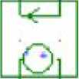
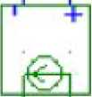
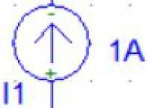
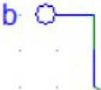
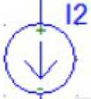
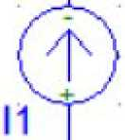
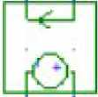
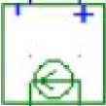

From PSpice circuit diagrams,
V_{th}= Voc = 0.457 IV
Isc = 0.2424A
ER_{th} mh 0.4571
=== 1.886Q
////// 0.2424
For maximum power transfer, Rl = Rth
H Rl= 1.8860
SPmax = _ (WI7r)^{A}2/4*Rth (0.4571)^{A}2/4*1.886 = 0.02769W = 27.696mw
Rth
121.18mA
J
457.10mV
L d
VA
1.886
228.55mV
121.18mA
Vth
0.4571V
Rl_ < 1.886
121.18mA
J
OV
Thevenin's equivalent of the circuit
Theoretical solution:
Vth :
IDC
1
AM
R1
114 29mA
d
R3
R4
114 29mA
457.14mV
342.86mV
BOO.OOmV
1 029A
800 OOmA
114 29mA
457 14mV
OV
R5
457.14mV
IDC
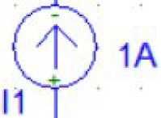
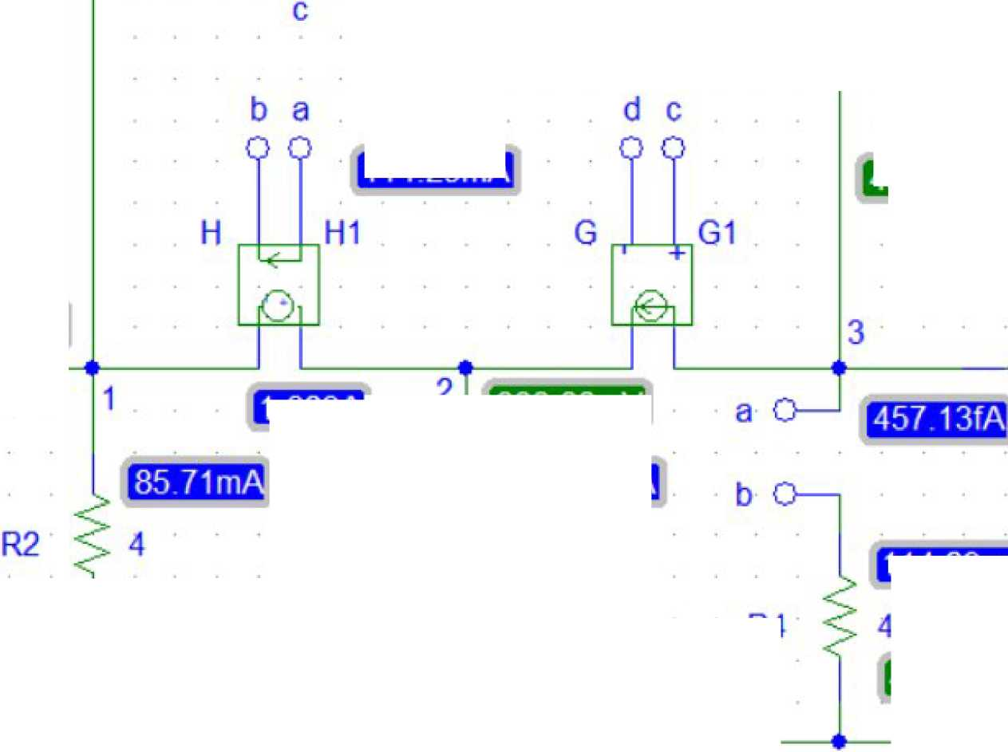
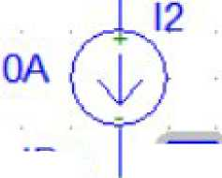

Applying KCL at supernode :
-3V1+ 4V2+4V3 = 4 .... (1)
From supernode :
-Vl +V2-V3 = 0 ... (2)
Applying KCL at node V3 :
4V1 - 3V3 = 0 ... (3)
Solving (1), (2), (3) we get,
VI = 0.3428V
V2 = 0.8V
V3 = Voc = 0.4571V
Vth = 0.4571V
484 85mV
R2
545.46mA
666 67mA
H1
121 21mA

A/Vv
R1
G1
R3
R4
15.15mA
-60.61 mV
530.30mA
1 000V
424 24mV
424 24mA
530.30mA
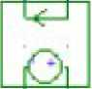
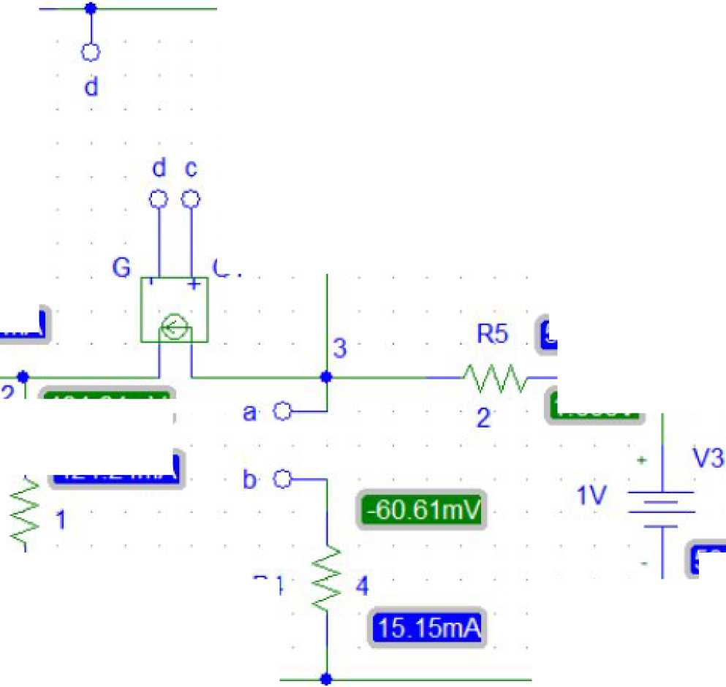

Applying KCL at Supernode:
-3Vi + 4V₂ + 4V₃ = 0 (1)

From Supernode:

-Vi + V₂ - V₃ = 0
(2)

Applying KCL at node V3 :
4V1-V3 = 2... (3)
Solving (1),(2) ,(3) we get,
- I = 0.485V
- 2 = 0.424V
- 3 = - 0.060V
lo = 1- V3 / 2 = 1- (- 0.060 }/2 = 0.53 A
Rth = vO/ iO = 1/ 0.53 = 1.886ohm
For maximum power transfer, RL = Rth
RL = 1.886ohm
Pmax = (IW/l)^{A}2/4*Rth = (0.4571)^{A}2/4*1.886 = 0.02769W = 27.696mw
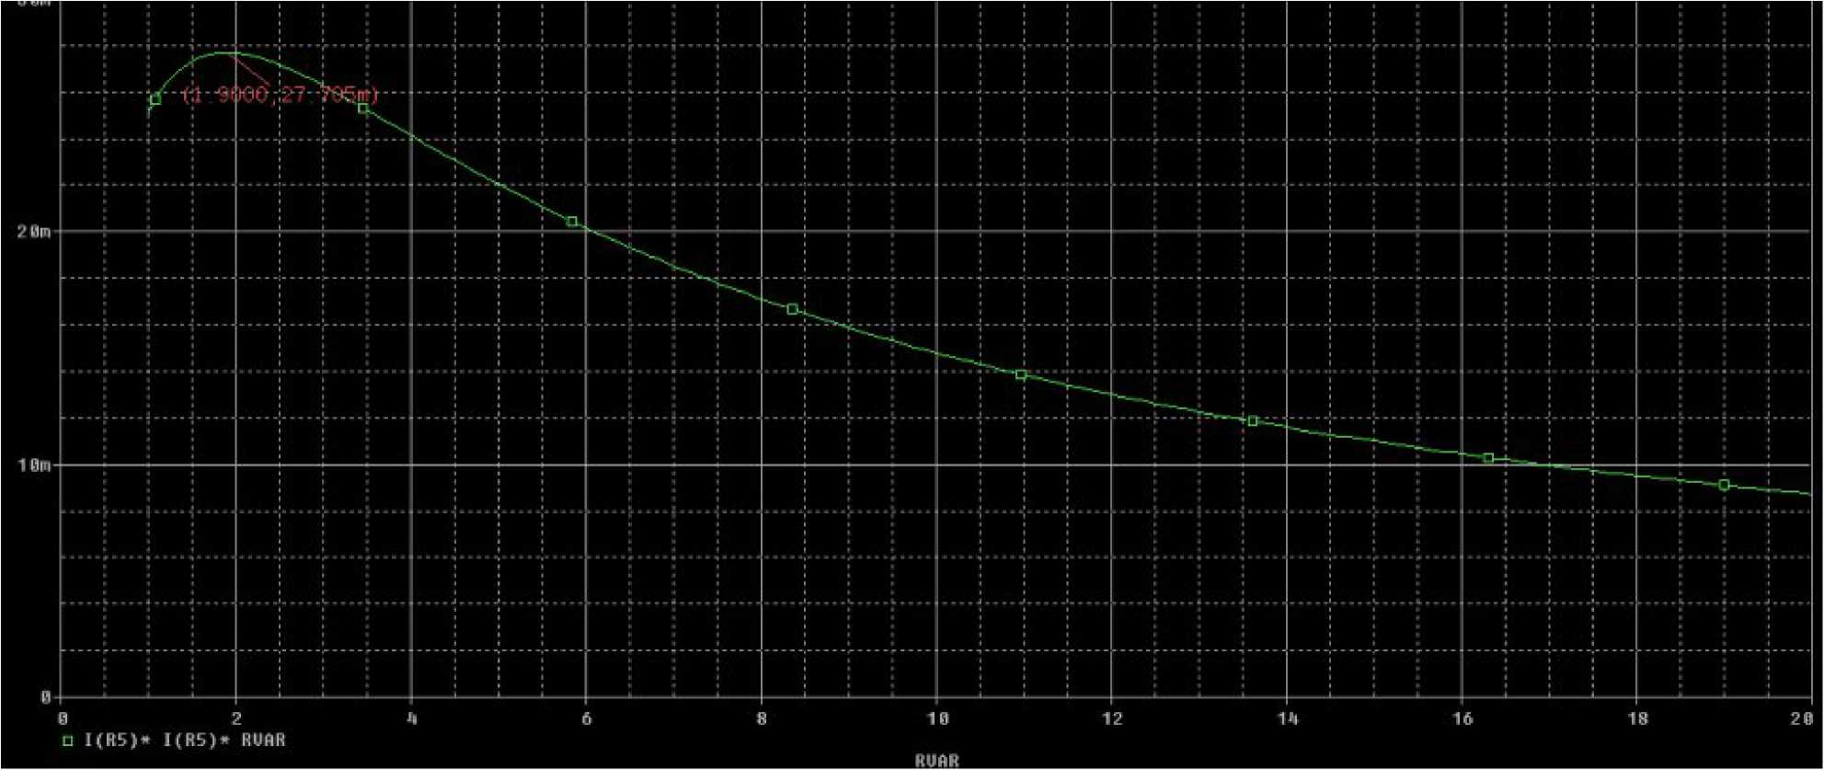

From PSpice Simulation with resistance sweep,
Rl= 1.90
Pmax “ 27.705mW
Comparison between the values of Rl and Pmax obtained in steps 2 and 3,
 | Step 2 | Step 3
Rl | 1 8860 | 1.90
Pmax | 27.696mW | 27.705mW

Comment: Values of Rl and Pmax obtained in steps 2 and 3 are pretty much the same.
Conclusion :
The main objective of the project was to analyze the maximum power transfer using PSpice. After comparingthe theoretically obtained values and PSpice measured values of Rrand Pmax, it is quite visible that both the values of Rl and Pmax are almost same.
Scanned with CamScanner

